STAGE B1 — MINI PROJECT B
  - SMRTTECH 4SC3 Smart Cities and Communities

Members:
- Jacob Kwan (400453713)
- Tommy Ouyang (400391487)
- Nicolas Jao (400450151)

This document contains all the evidence required to prepare Stage B1 as part of the Mini Project B. Decisions that impact the development of Stage B1 are outlined and agreed upon by all group members. All work was done by the members of Group 2, only using AI when required by the instructions.

Date: 11/05/2026

Concept
For this project, our group has selected to model a passenger locomotive—specifically a GO Train, as these frequent the Oshawa GO station.
The planned location of our generated assets will be as follows:
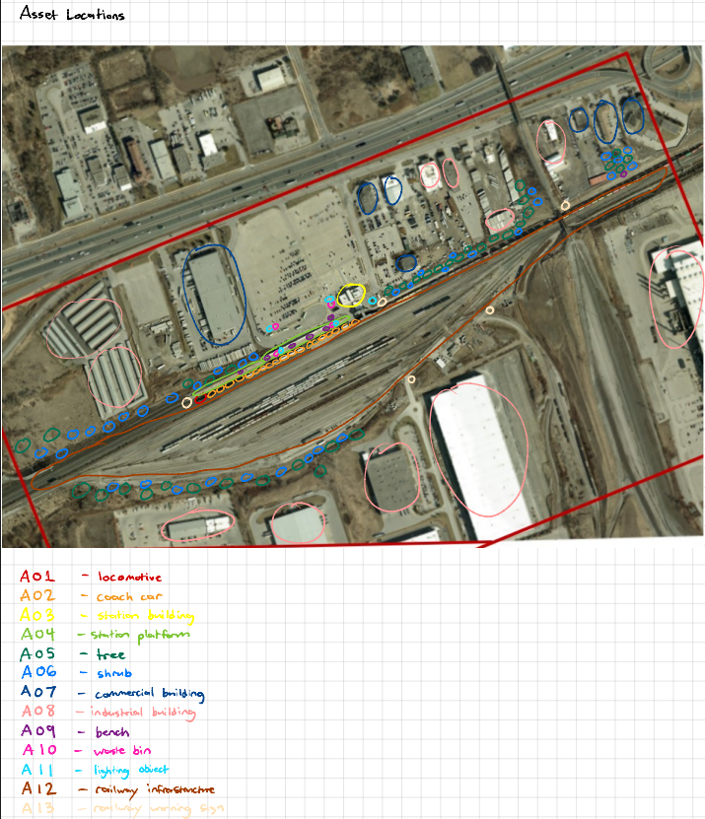
Asset Inventory
Asset ID | Asset Name | Responsible Member | Dimensions (in m) | Blender/FBX Path | Method/Source | Preview Image
A01 | Locomotive | Nicolas | 20.73L x 4.8W x 6.43H | .\Group02_StageB1\02_Exports\A01_Locomotive | Meshy AI + Blender Formatting (from Google Images) | 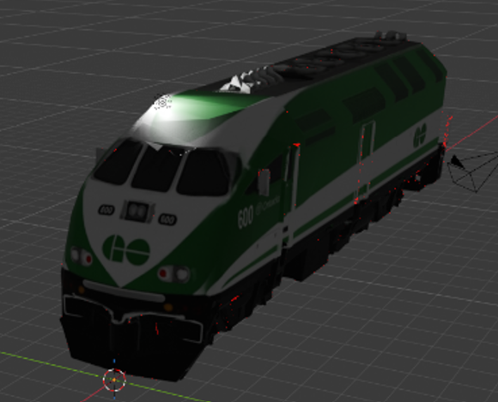
A02 | Coach car | Nicolas | 25.9L x 3.39W x 5.0H | .\Group02_StageB1\02_Exports\A02_CoachCar | Meshy AI + Blender Formatting (from Google Images) | 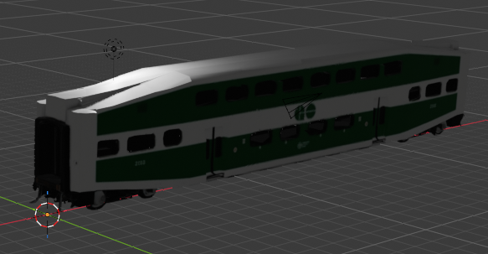
A03 | Station building | Nicolas | 55.44L x 36.0W x 14.3H | .\Group02_StageB1\02_Exports\A03_StationBuilding | Meshy AI + Blender Formatting (from Google Images) | 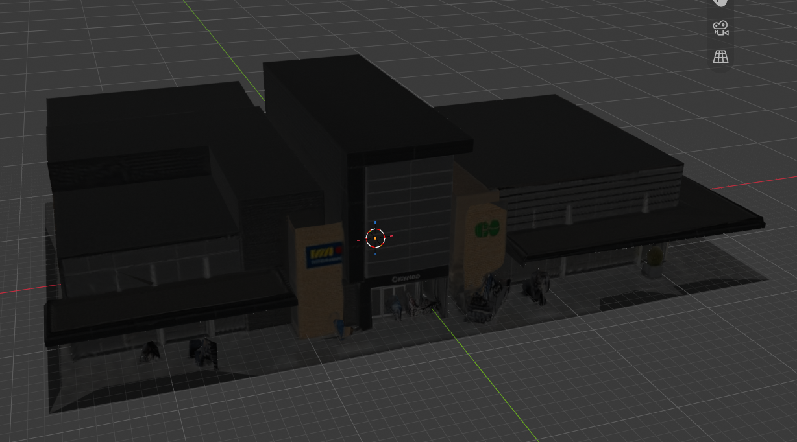
A04 | Station platform | Nicolas | 9.05L x 4.88W x 2.17H | .\Group02_StageB1\02_Exports\A04_StationPlatform | Meshy AI + Blender Formatting (from Google Images) | 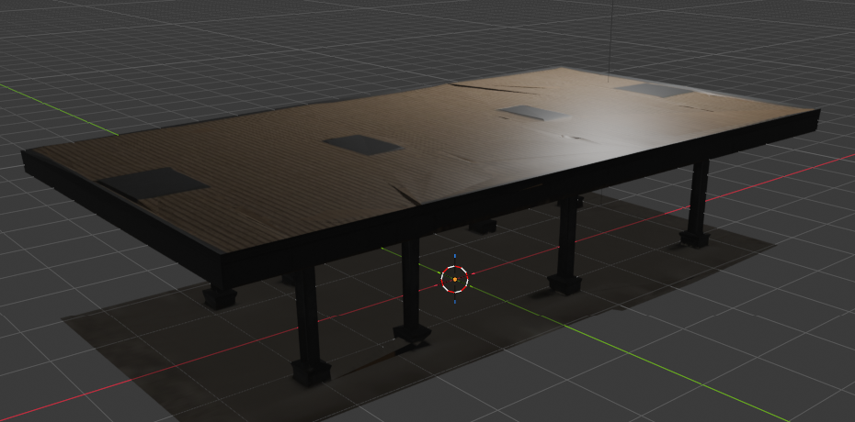
A05 | Vegetation -Tree | Tommy | 1.1L x 1.08W x 1.89H | .\Group02_StageB1\02_Exports\A05_Tree | Meshy AI + Blender Formatting (from ChatGPT) | 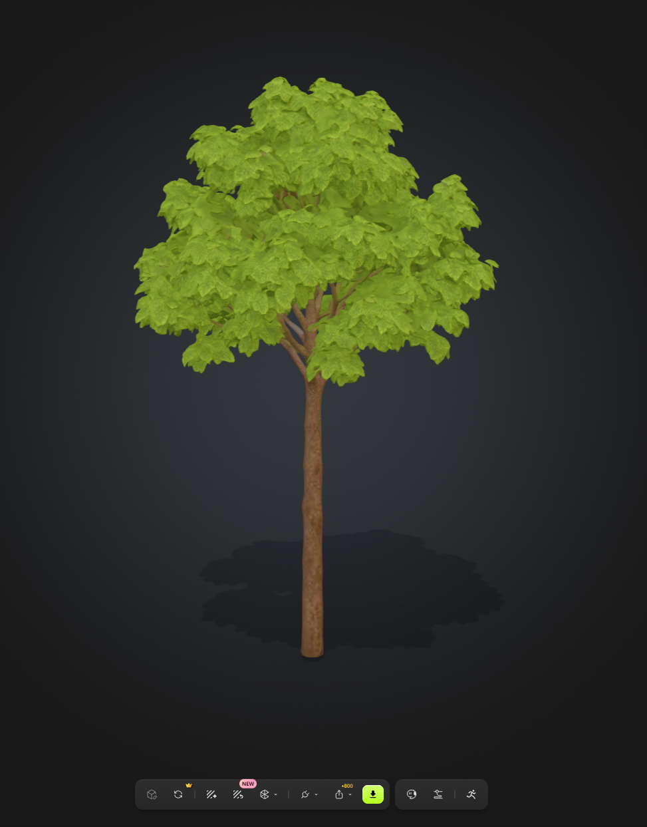
A06 | Vegetation -Shrub | Tommy | 1.75L x 1.78W x 0.741H | .\Group02_StageB1\02_Exports\A06_Shrub | Meshy AI + Blender Formatting (from ChatGPT) | 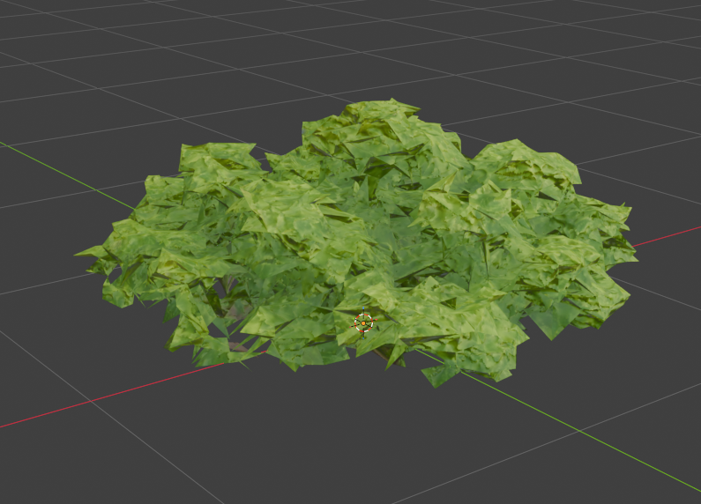
A07 | Surrounding buildings - commercial | Tommy | 16L x  10W x  7H | .\Group02_StageB1\02_Exports\A07_CommercialBuilding | Meshy AI + Blender Formatting (from ChatGPT) | 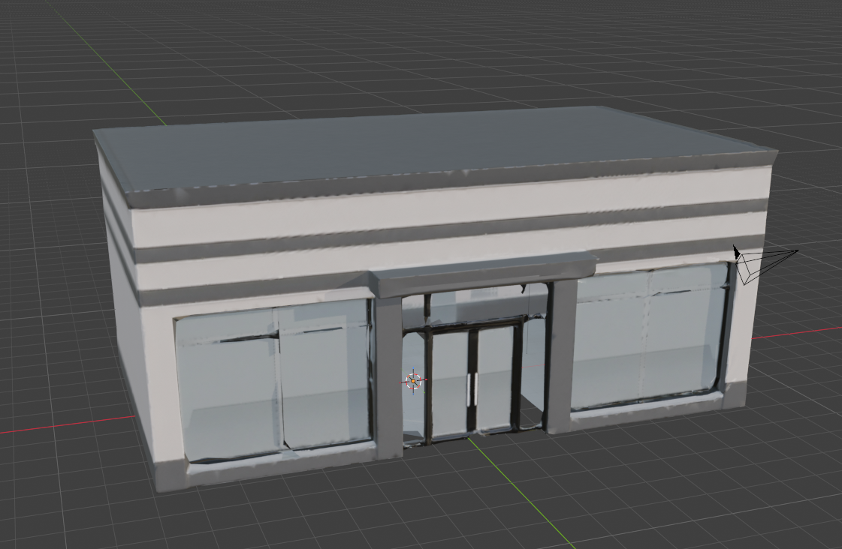
A08 | Surrounding buildings -industrial | Tommy | 25L x  15W x  9H | .\Group02_StageB1\02_Exports\A08_IndustrialBuilding | Meshy AI + Blender Formatting (from ChatGPT) | 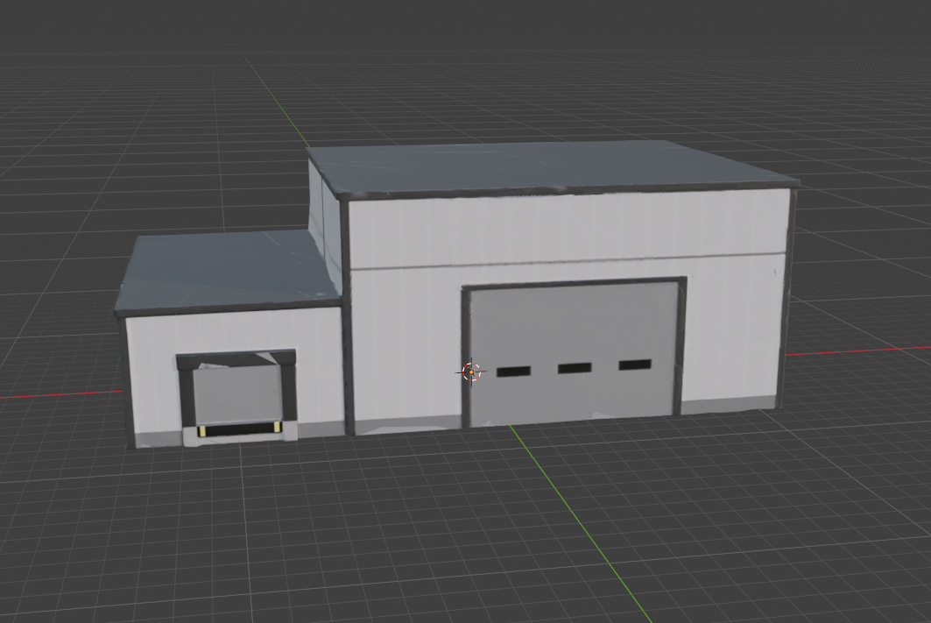
A09 | Street furniture -bench | Tommy | 2.5L x  0.8W x  1.5H | .\Group02_StageB1\02_Exports\A09_Bench | Meshy AI + Blender Formatting (from ChatGPT) | 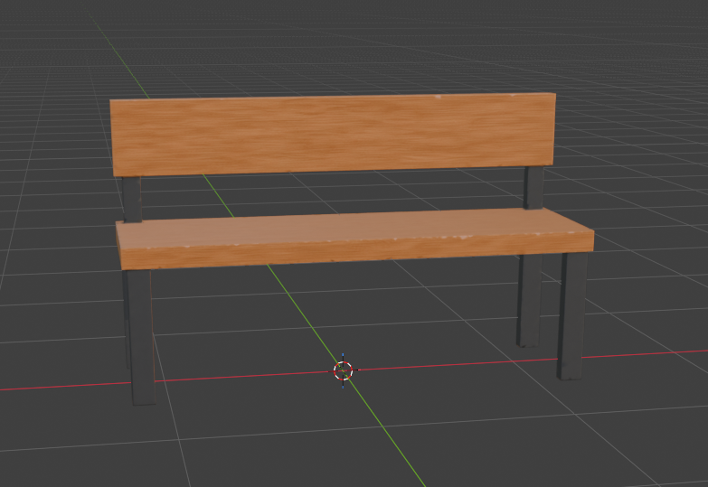
A10 | Street furniture – Waste Bin | Tommy | 1L x  0.9W x  1.5H | .\Group02_StageB1\02_Exports\A10_WasteBin | Meshy AI + Blender Formatting (from ChatGPT) | 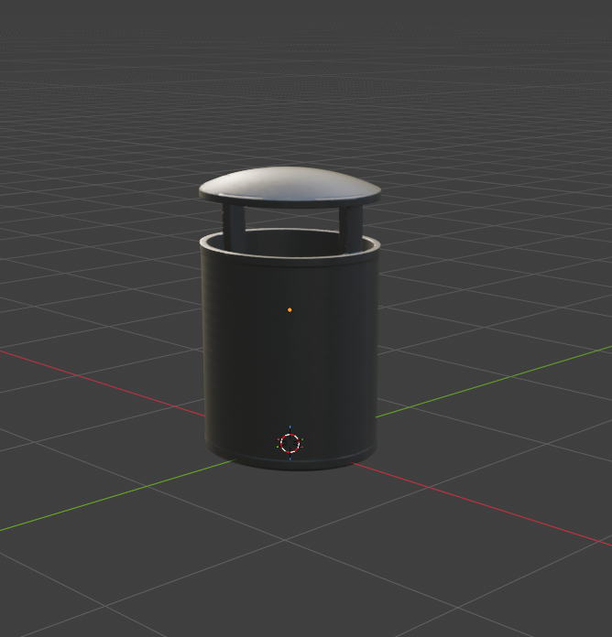
A11 | Lighting object | Jacob | 2.34L x  2.34W x  15H | .\Group02_StageB1\02_Exports\A11_LightingObject | Meshy AI + Blender Formatting (from Copilot) | 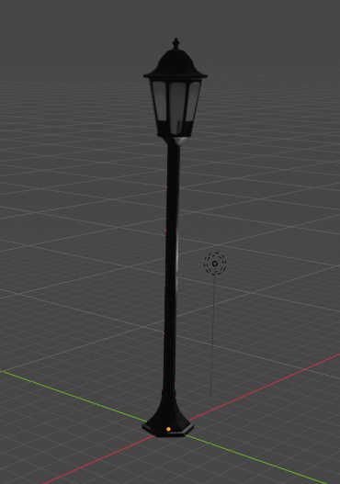
A12 | Railway infrastructure | Jacob | 1.9L x  0.113W  0.806H | .\Group02_StageB1\02_Exports\A12_RailwayFence | Meshy AI + Blender Formatting (from Copilot) | 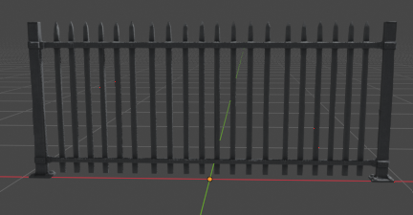
A13 | Railway warning sign | Jacob | 0.575L x  0.0485W x  2.41H | .\Group02_StageB1\02_Exports\A13_WarningSign | Meshy AI + Blender Formatting (from Copilot) | 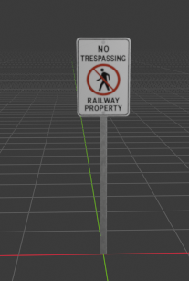

Milestone 1
A01 Prompt
No prompt was used to generate the 2D image as we did not use generative AI to create the 2D image.
Instead, the source for the reference image was taken from Google Images, from this specific site: https://ignitiondigital.com/portfolio/go-transit-locomotive
Reference Image
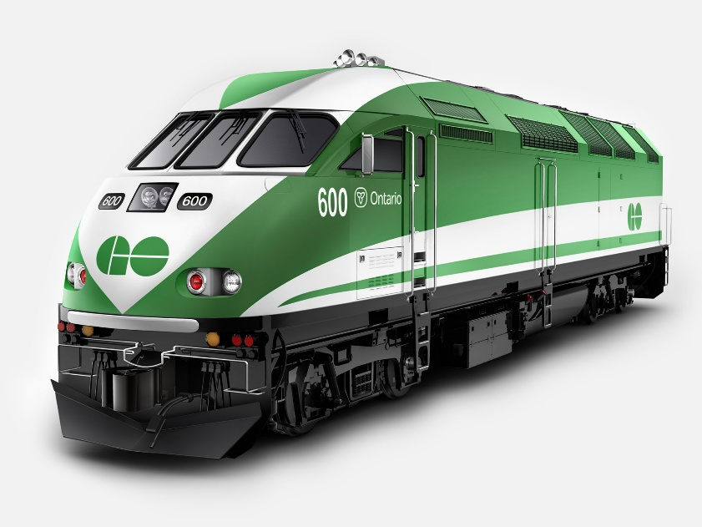
This is the reference image we used to create the locomotive (A01). We fed this into Meshy AI and it generated the 3D model. We used the same reference image as an image input for the texture of the model.
Generated/Textured Previews
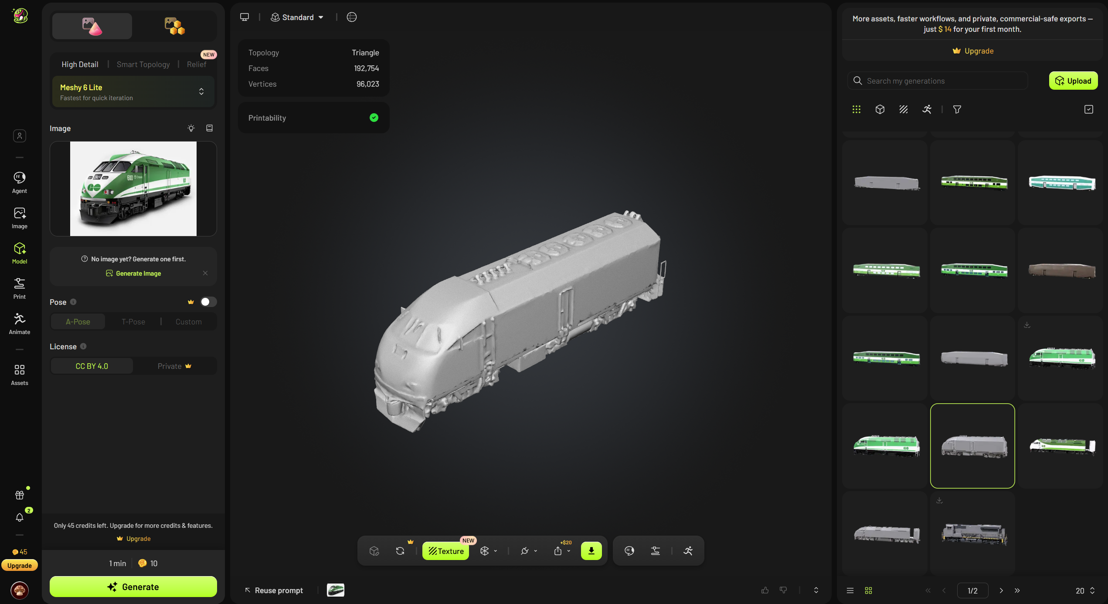
This is the 3D model Meshy AI generated with our 2D reference image.
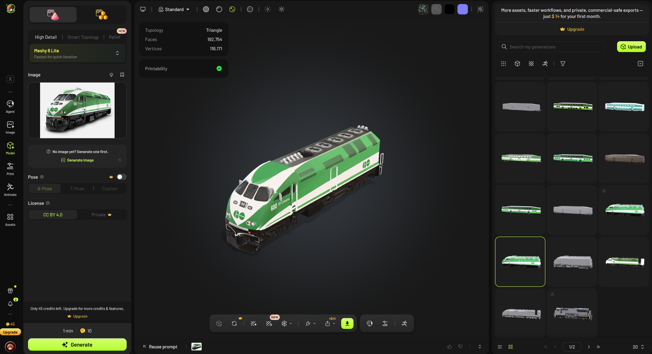
This is the 3D model with the texture now added, which we created through an image input of the same 2D reference image.
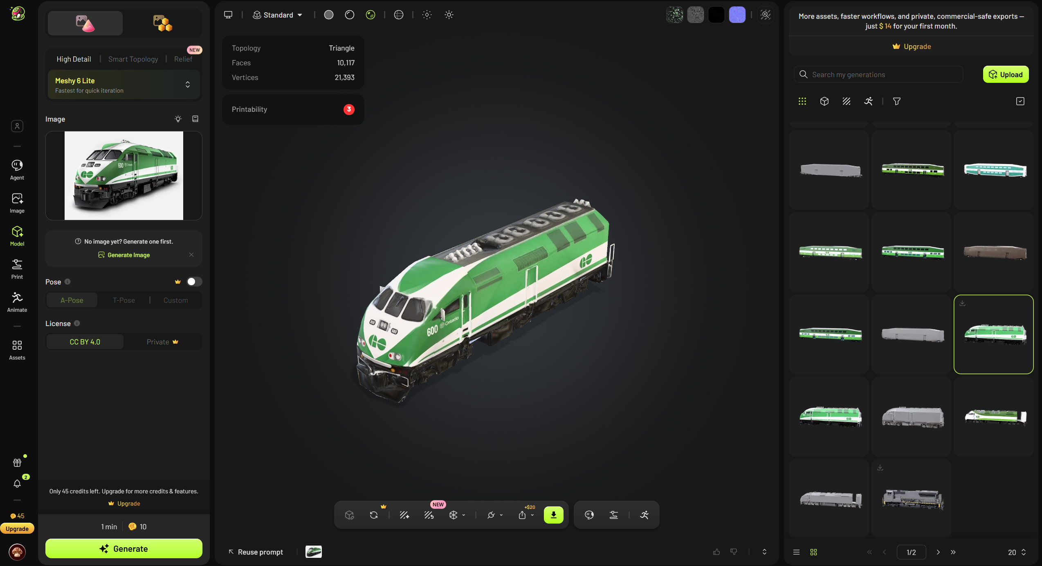
This is the final re-meshed 3D model we downloaded. As you can see, the number of faces and vertices have drastically decreased. This was done to optimize the models, as a greater number of faces and vertices on each object can slow down the game engine.

Before-and-After Mesh Statistics
Version | Faces | Vertices | Notes
Original (Meshy) | 192,754 | 116,171 | Full detail
Reduced | 10,117 | 21,393 | Detail holds surprisingly well. Text is slightly blurrier. Overall texture still looks clean.

We chose this first generated model of the locomotive from Meshy AI because it did it surprisingly well on the first try (unlike A02, the coach car, which took many tries to get a good model and texture). The text looks clean and is readable, the colours are vibrant, and the shape of the locomotive is as desired.
There were no changes to external models because the 2D reference image we chose, our only external model input for Meshy AI, produced a reasonably well-made model and texture on the first try.

Milestone 2
Before-and-After of Scale/Alignment
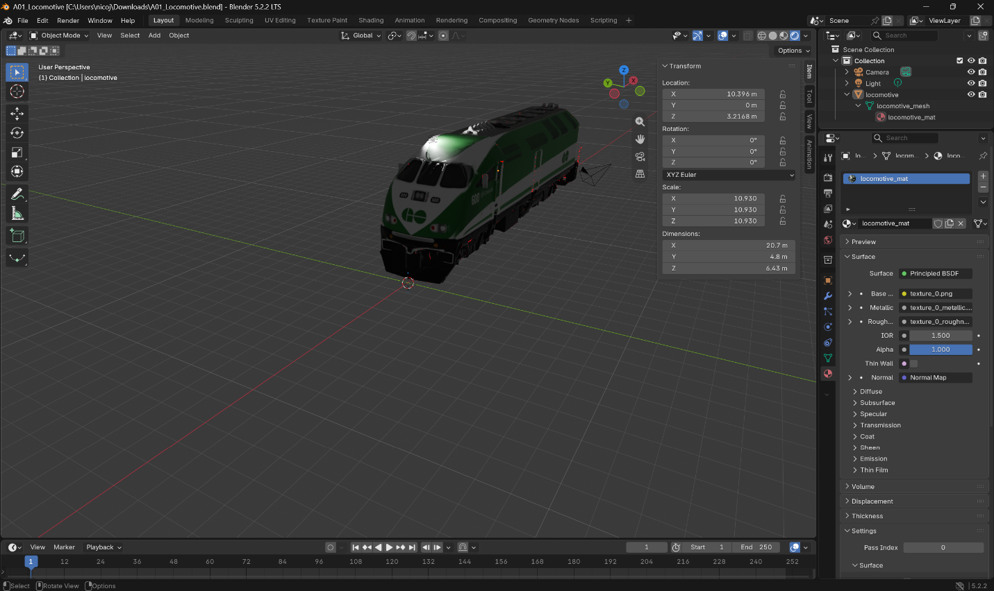
This is the fbx model imported into blender before the scaling transforms have been applied.
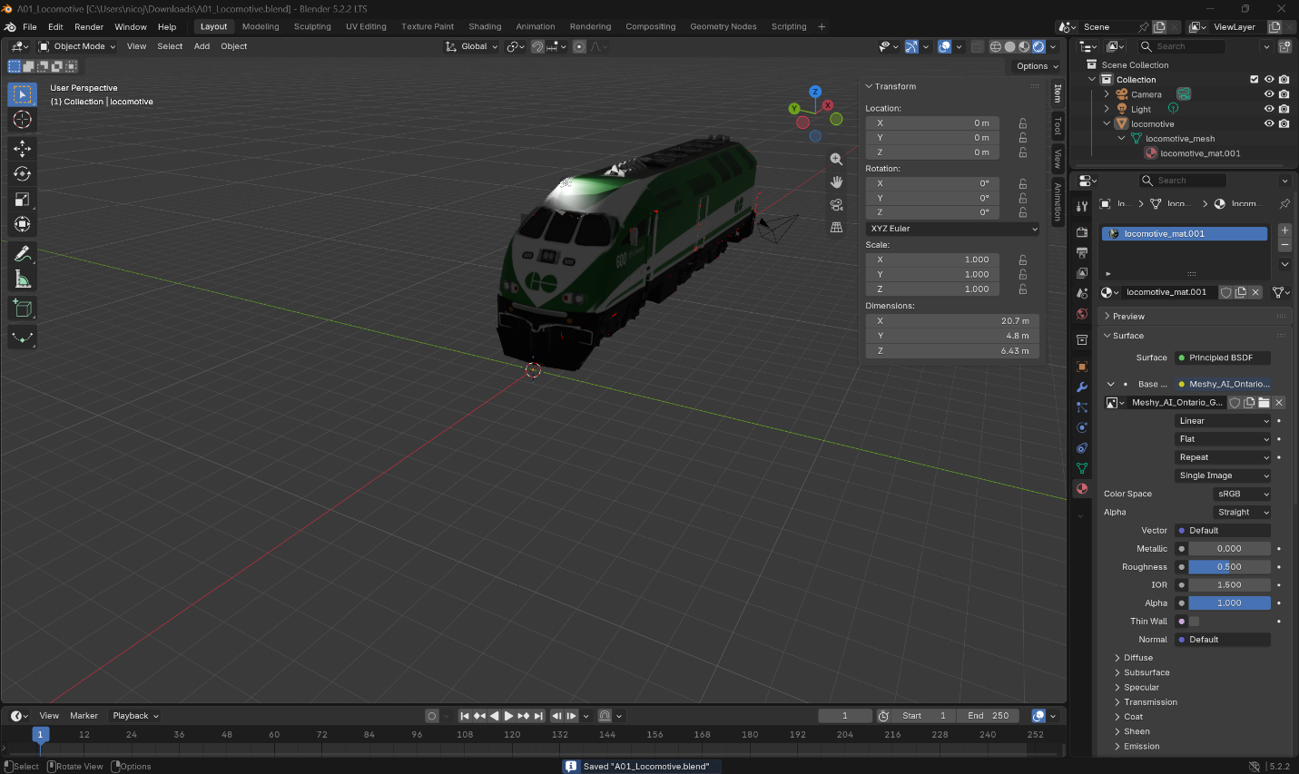
This is the model after scaling it properly and applying all transforms. As you can see, we also renamed the files properly and created a new material to add the texture. It is also aligned on all axes.

Export Settings
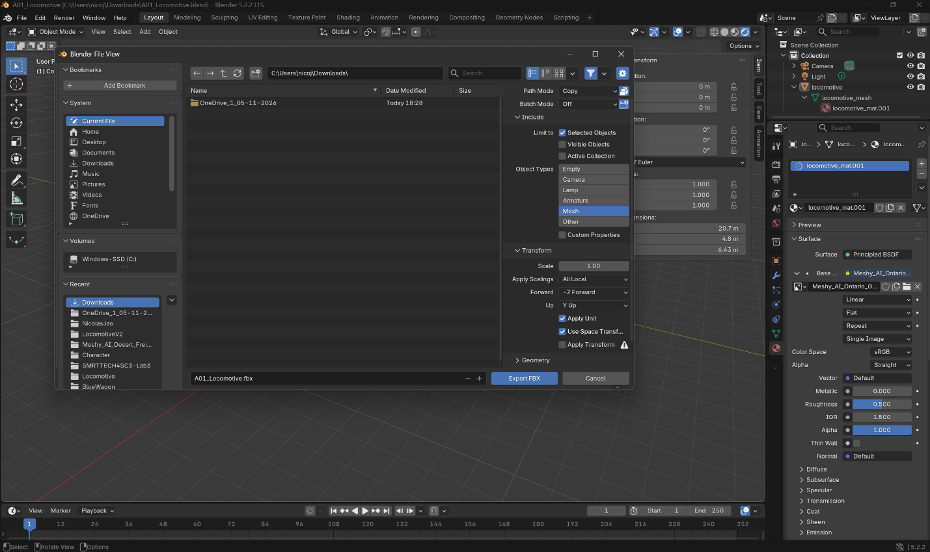
These are the export settings we used when exporting the final model as an fbx.
This process was repeated for all assets.

Unresolved Issues
There were no unresolved issues. There were optional features we chose not to apply, and some features where we did not have to do anything, but we understand (UV mapping).

